Q1

1. a. Hierarchical Clustering Min: compare one point with another point that is inside a cluster and choose the closest one

Hierarchical Clustering Max: compare one point with another point that is inside a cluster and choose the furthest one

Hierarchical Clustering Average: For this one, we need calculate the average of distance between one point with the rest points that is inside the cluster

So the resulting models are different for each method

b. Choose the max method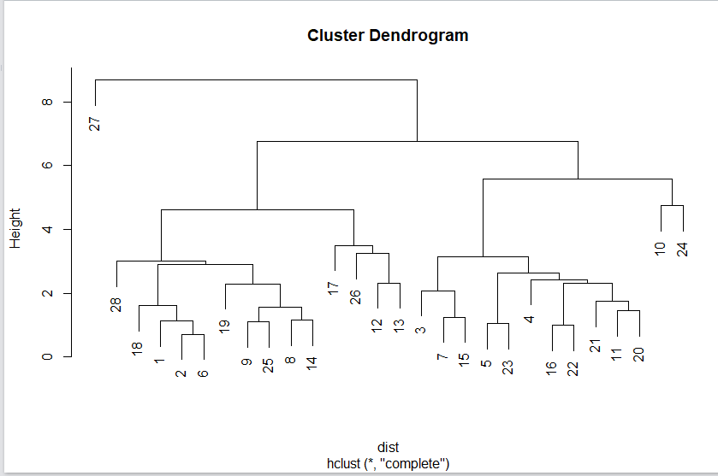

I will cut at height of 1 to make the cluster

Q2.

a. 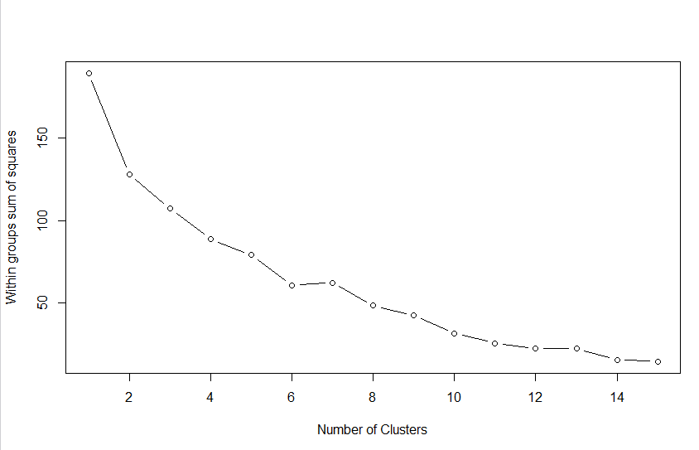

If I use the elbow method, I would choose k=8

b. 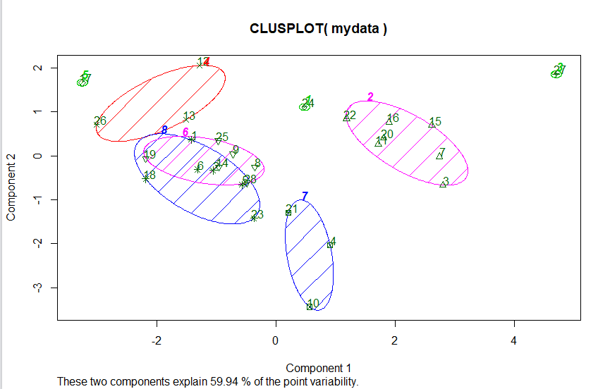

cluster1: 24

cluster2: 22, 20, 16, 15, 11, 7, 3

cluster3: 27

cluster4:12, 26, 13

cluster5:17

cluster6:19, 25, 9, 8, 14, 28

cluster7:21, 10, 4

cluster8:18, 1, 6, 2, 14, 5, 23

c. If I do it again, it is different

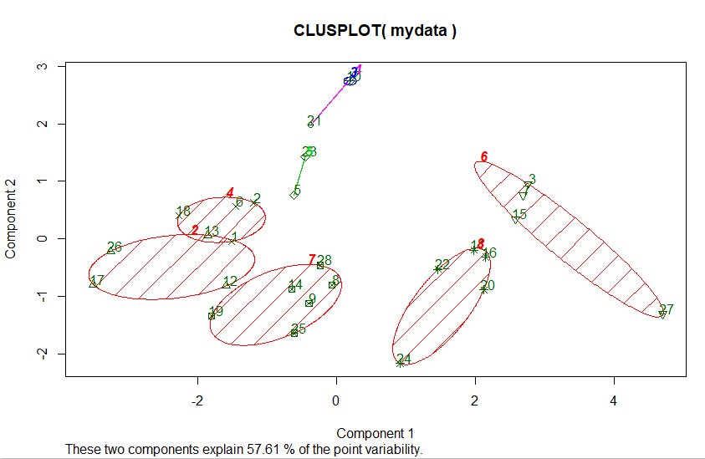

Q3 I think they are similar, because we are finding clusters, if those points are similar to each other, they are going to be in the same cluster no matter what method we use.